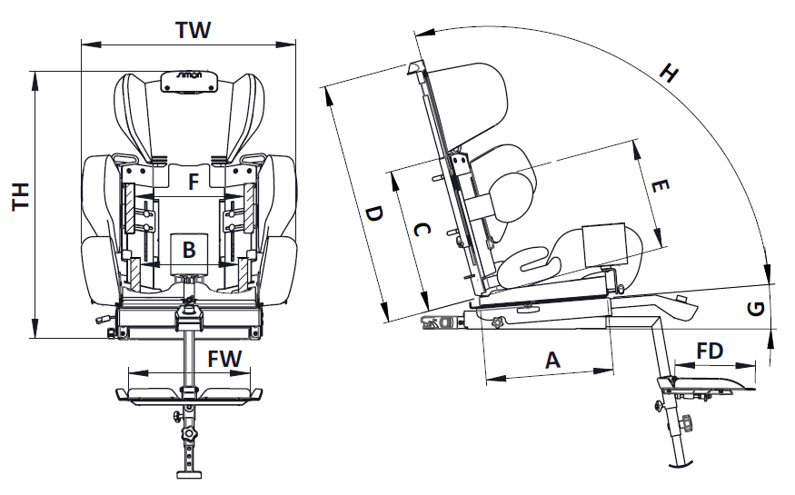



| Dimension | Symbol |  |
| --- | --- | --- |
| Seat depth | A | 27 – 37 cm |
| Seat width | B | 18 - 28 cm |
| Back height | C | 33 – 53 cm |
| Headrest height | D | 55 – 75 cm |
| Lateral support height | E | 22 – 33 cm |
| Distance of lateral support | F | 15 – 29 cm |
| Seat angle (tilt) | G | 0° - 10° |
| Back angle | H | 90° - 115° |
| Total width | TW | 54 – 62 cm |
| Total height | TH | 63 – 77 cm |
| Footrest platform depth | FD | 20 cm |
| Footrest platform width | FW | 32 cm |
| Minimum user height |  | 100 cm |
| Maximum user height |  | 150 cm |





| Maße | Symbol |  |
| --- | --- | --- |
| Sitztiefe | A | 27 – 37 cm |
| Sitzbreite | B | 18 - 28 cm |
| Rückenhöhe | C | 33 – 53 cm |
| Kopfstützenhöhe | D | 55 – 75 cm |
| Höhe Thoraxpelotten | E | 22 – 33 cm |
| Abstand Thoraxpelotten | F | 15 – 29 cm |
| Sitzwinkel (Neigung) | G | 0° - 10° |
| Rückenwinkel | H | 90° - 115° |
| Gesamtbreite | TW | 54 – 62 cm |
| Gesamthöhe | TH | 63 – 77 cm |
| Fußbanktiefe | FD | 20 cm |
| Fußbankbreite | FW | 32 cm |
| Mindestgröße des Benutzers |  | 100 cm |
| Maximale Benutzerhöhe |  | 150 cm |